**Travis Ritter, Section: 01**

**2.11**

**addi $t0, $s6, 4 (I - Format)**

OP: 001000, rs: 10110, rt: 01000, immediate: 0000000000000100

**8 22 8 4**

**add $t1, $s6, $0 (R – Format)**

OP: 000000, rs: 10110, rt: 00000, rd: 01001, shamt: 00000, funct: 100000

**0 22 0 9** 0 32

**sw $t1, 0($t0) (I – Format)**

OP: 101011, rs: 01000, rt: 01001, immediate: 0000000000000000

**43 8 9 0**

**lw $t0, 0($t0)**

OP: 100011, rs: 01000, rt: 01000, immediate: 0000000000000000

**35 8 8 0**

**add $s0, $t1, $t0**

OP: 000000, rs: 01001, rt: 01000, rd: 10000, shamt: 00000, funct: 100000

**0 9 8 16**  0 32

*The question only asked for OP-code, rs, rt, and rd/immediate value depending on the format, but I just did the full thing for the R type format, because that is what I am used to.

**2.14**

**000000 | 10000 | 10000 | 10000 | 00000 | 100000 (R – Format)**

OP: 0, rs: 16, rt: 16, rd: 16, shamt: 0, funct: 32

**add $s0, $s0, $s0**

**2.16**

**00000 | 00011 | 00010 | 00011 | 00000 | 100010 (R – Format)**

**sub $v1, $v1, $v0**

**2.17**

**100011 | 00001 | 00010 | 0000000000000100 (I – Format)**

**lw $v0, 4($at)**

**2.21**

**nor $t1, $t2, $0**

**2.26**

**2.26.1**

**$s2 would be 20**

**2.26.2**

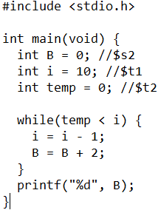

**2.26.3**

Number of statements in the loop = 5

The loop will run N times, so N * 5

But the slt and beq will need to be run one last time making it: (**5 * N) + 2**